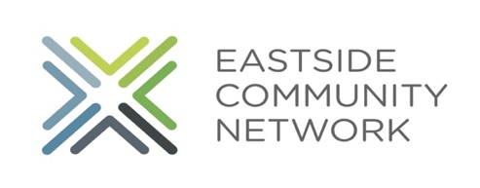Are you looking for a job this summer? Eastside Community Network is hiring about 30 youth this summer!

The job will be 20 hours a week for six weeks beginning on July 5th and running until August 13th. Youth will work on projects Monday-Thursday and receive paid training on Friday from 9 am-1 pm. The program will in person and hosted at our Conner site (4401 Conner). ECN will take all Covid safety measures advised such as social distancing, masks (which we provide), cleaning and disinfecting often, staff testing and providing hand sanitizer throughout our building. Youth will be paid $9.65 an hour for 120 hours during the summer. The program will provide 2 work shirts, morning snack and lunch, work readiness training, skill and career assessment, financial literacy training, resume writing and interview training-there is also an option to be involved in an unpaid Summer Enrichment program following the work program each day. On August 13th , we will have a celebration to share our experience with the community, family and friends (this will likely be virtual).
In order to qualify you must live in ECN's project area known as the LEAP district (Jefferson Ave and I- 94/ Alter Rd. to Mt. Elliott) or attend Southeastern High School. You must also have a family income that is equal or less than 50% of median income by HUD standards (this varies on the size of the family anywhere from $28,400 to $46,800) or have additional risk factors including academic issues, disability, unemployment or trauma. You must provide your social security card, report card, and documents that can prove age and residency (some examples of those documents include State ID, birth certificate, passport, bank records with address, medical records, school transcript or report card). We will schedule at time to bring in this documentation so that we can space out youth. Youth will be paid via direct deposit therefore a bank account is required. One Detroit Credit Union partners with us to open youth accounts if you do not current have one. A parent/trusted adult (with an id) is required to open an account for anyone under 18 years of age.
Youth will report for work to ECN on July 5th at 9:00 am. Youth are allowed two absences during the summer but are expected to notify the program ahead of time for those absences. Youth will be paid via direct deposit on a bi-weekly basis.
Youth will be working on developing community projects- they will be learning about the process that community developers use to engage community, about the projects that ECN is involved in and will talk to community developers as well as other experts with tools such as graphic design, writing, and presenting to groups.
For more information or to apply contact Tanya Aho- Director of Youth Development at Eastside Community Network at 313-590-4785 or taho@ecn-detroit.org.

